Date: MAY 31 2021 File: C:\Karapetyan\18500 Фальц-ножы и лыжи - в расчет\03_program\3\18500 Фальц-ножы и лыжи 3002.NST

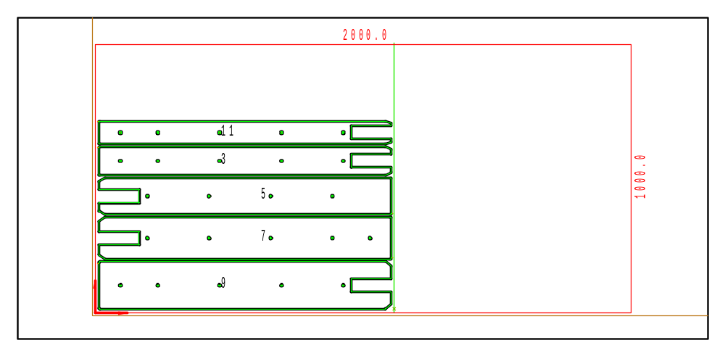

PART INFO
NC File Name: Ê!Å;Ä2RÅ0Ì-ÌÌÌ3002&ËÍ
Draft no.: | Version:
Order no.: | Description:
SHEET Number of sheets: 1
Material: Stainless | Sheet size: 2000 X 1000 | T= 3.0
No. of parts: 5 | Part size:
Part weight: | Sheet weight: 46.80 kg
MACHINE:
MODEL: ML3015EX |  | Con. name: SUS304 |  | Table name: ML45CF_R_EX
Gas: N2H | Lens: 7.5 Inches |  | Nozzle diameter: 1.7
Speed: 4000 |  | Used laser power: 4500 |  | Beam diameter (kerf): 0.32
PROGRAM
Number: 4169 | File size: 41163 | Programmer:
Notes:
JOB TIME (min:sec)
Travel: 00:15 | Cut: 03:48 | Pierce: 00:34
Travel way: 12049 mm | Cutting way: 0 mm | Pierce Qty.: 29
Total time: 04:38

 | Part name | DX | DY | QTY
9 | Ê#Å;Ì180ÌÌÌcurv_EËÍ | 1090 | 176.1 | 1
7 | Ê#Å;Ì160ÌÌÌcurv_9ËÍ | 1090 | 156.1 | 1
5 | Ê#Å;Ì140ÌÌÌcurv_-ËÍ | 1090 | 136.1 | 1
3 | Ê#Å;Ì110ÌÌ_rËÍ | 1090 | 106.1 | 1
11 | Ê#Å;Ì90ÌÌÌcurv_QËÍ | 1090 | 86.1 | 1

